**Titles Are in Times New Roman, and Size-16: Line Spacing Is Fixed to Single, and Before and After Paragraph Spacing Is Set to 0pt**

Name of corresponding author

University name, University Location

Your institution email address

If there is a second author, follow the

same format as above and place the details here

Type your abstract here and keep it in block format (i.e., no paragraph indentation), left aligned and text single-spaced; the length should be between 250 to 300 words. No abstract is required if the manuscript is a Research Note. The abstract should describe all sections of your paper (if your paper is a research paper, this would traditionally be the Introduction, Method, Results, and Discussion). Once you have read through this document, you can type directly in here and delete what is not necessary for your paper. Upon completion, please fill in the online submission form. **Proofread** your paper before submission. Serious grammar/spelling/formatting mistakes influence the decision on whether your paper is accepted.

**Keywords:** type five keywords here separated by commas

**Headings**

**Level 1 Heading**

Level headings, and most of the remaining formatting of this template are in APA Style (American Psychological Association, 2009). Level 1 headings should be in title case (see footnote 1), boldface and 12pt font. Leave a line after the Level 1 Heading. Headings are for titling major sections of your manuscript. Note that the following are Level 1 headings “Introduction,” “Discussion” (or whatever the last section is titled, e.g., “Conclusion”), “References,” and “Appendix,” but are **not** numbered. If your paper has additional subheadings, use the format below and make sure to move titles to the next page when no text is below them.

*Level 2 Heading 2*

Level 2 headings should be in title case (see footnote 1), italicised, 12pt font, and left-aligned.

**In-text References**

Note that multiple in-text citations should be in **alphabetical order**, e.g. (Austen, 1813; Bourdieu, 1977; Smith, 1995) for publishing. If there are any uncertainties regarding formatting or referencing not discussed, the most up-to-date APA publishing manual should be consulted. The [Online Writing Lab](https://owl.english.purdue.edu/owl/resource/560/01/) (OWL; “General APA guidelines,” 2013) is also a helpful resource for general APA Style queries. If you cannot find an answer to your question(s), contact the CORERJ Editors at [corerj@educ.cam.ac.uk](mailto:corerj@educ.cam.ac.uk). You can also refer to the previous volume of the journal for formatting details that can be found on the CORERJ webpage at <http://corerj.educ.cam.ac.uk>

**Stylistic Elements**

* *Paper Size:* Make sure the paper size setting is A4 (in Microsoft Word go to File > Page Set up > Page Size and select “A4” from the dropdown menu). Margins are 2.54 cm from the top, bottom, left, and right of the page.
* *Content specific terminology:* Italicise specialised or context specific terminology (which will need to be defined) upon their introduction; subsequent usage of these words should be in normal formatting. Some authors may wish to use “scare quotes”, that is double (or single) quotation marks rather than italicise terms. This is acceptable, as long as consistency is maintained throughout the paper.
* *Quotation marks:* When short verbatim excerpts (under 40 words) are quoted from another source, use **double quotations**, followed by standard APA referencing, as in “I’ll use this space to mention that numbers under 10 should be spelled out, as in “nine” rather than “9”, with some exceptions, as discussed in Appendix A)” (Author & Author, 2014, p.5). In cases where quotations are followed by a punctuation mark (e.g., a period or comma), place the punctuation mark inside the end quotation mark (e.g., “Text.” or “Text,”). An example of how longer quotes should be treated is given in the “Tables and Figures” section below.
* *Lists:* Lists follow traditional APA Style. Specifically, numbered lists and bulleted lists are acceptable. Each list item is followed at the end by a comma, semicolon, or period depending on the phrasing of the list. Use periods after numbers, rather than parentheses:

1. First item;
2. Second item;
3. Third item;

For lists within sentences use, letters with parentheses: (a) please use standard British English spelling in your manuscript; (b) define specialist terminology; (c) reference the use of ethical guidelines (if applicable/human participants were used); (d) seek permission from copyright holders to use their material, and (e) do not submit material you have submitted or published elsewhere.

**Tables and Figures**

Below are guidelines and some examples of how tables and figures should be formatted.

*Tables*

The instructions for table formatting also provide an illustration of how to use long quotes (over 40 words). Notice how quotation marks are eliminated, each line is indented the same amount as a new paragraph (i.e., 1.27 cm from the left), and spacing remains at 1.5.

Data in a table that would require only two or fewer columns and rows should be presented in the text. More complex data is better presented in tabular format. In order for quantitative data to be presented clearly and efficiently, it must be arranged logically, e.g. data to be compared must be presented next to one another (before/after, young/old, male/female, etc.), and statistical information (means, standard deviations, *N* values) must be presented in separate parts of the table. If possible, use canonical forms (such as ANOVA, regression, or correlation) to communicate your data effectively (“APA tables and figures 1,” 2013, para. 8).

Table 1, provides an illustration of how you might use a table to present empirical findings.

|  |  |  |
| --- | --- | --- |
| Table 1 | | |
| *Titles Are Italicised: Use Title Case* | | |
| Header |  |  |
| Subhead | Column Head | Column Head |
| Row 1 | # | # |
| Row 2 | # | # |
| Row 2 | # | # |
| *Note.* Any notes about your table go here. This table is only an example and there may be more rows or columns depending on your results. Font size here is 10 pt, lines are single-spaced, and the paragraph spacing is “1pt” for “Before” and “0pt” for “After” (keep the line spacing within the table at 1.5). Notice there are no outside boarders and the titles “Table 1” and “Titles Are Italicised: Use Title Case” are within the table and in their own separate row. This “Note” section is also is also in a separate row within the table. | | |

*Figures*

Figure 1 is an example of how images may be presented in your article. Notice the titling is opposite from that for tables (i.e., “*Figure 1*” is italicised, but the title is not). If you wish to include a box in your manuscript, the formatting is similar to figures, with the exception of the title placement (see Box 1 below).

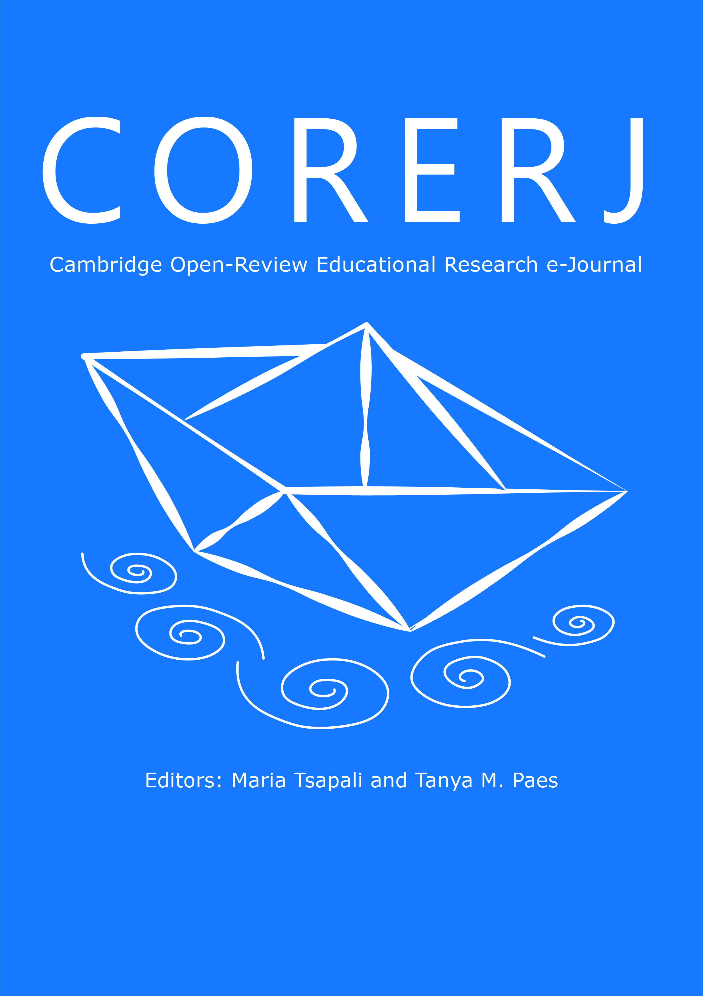

*Figure 1.* Title of figure should be in sentence case (i.e., no capitals unless proper nouns are used). Centre the title as well as the image; leave one space between the title and the image and keep the figure and figure title on the same page (in cases where this may occur, move the image to the next page with the title as was done here)

*Box 1.* Title of box should be in sentence case and left justified

* This is basically a Tex Box with a border of 1pt
* Centre the box on your page

*Please note that the CORERJ Editorial Board may need to make some adjustments when converting you paper to the final PDF version. If there are any significant changes, you will be notified about them.*

**References**

American Psychological Association. (2009). *Publication Manual of the American Psychological Association* (6th ed.). Washington, DC: American Psychological Association.

APA tables and figures 1. (2013). *Online Writing Lab*. Retrieved May 21, 2014, from https://owl.english.purdue.edu/owl/resource/560/19/

General APA guidelines. (2013). *Online Writing Lab (OWL)*. Retrieved May 21, 2014, from https://owl.english.purdue.edu/owl/resource/560/01/

Lee, C. (2012). Title case and sentence case capitalization in APA Style. *APA Style*. Retrieved June 7, 2014, from http://blog.apastyle.org/apastyle/2012/03/title-case-and-sentence-case-capitalization-in-apa-style.html

SOSW Writing Support. (2014). *Updated APA numbers in a nutshell* (pp. 1–2). University of North Carolina. Retrieved June 7, 2014, from http://ssw.unc.edu/students/writing

The title “References” should be a Level 1 heading but in **11pt font**. If you are using a citation manager (e.g., EndNote, Mendeley, or Zetoro), most of the work will be done for you and all you need to do is specify the formatting style to be displayed in APA Style. However, you should look over the reference list produced by your citation manager to make sure the formatting is correct (e.g., authors names are not all capitalised, titles are not in quotations etc.) and information is not missing (e.g., periodical volume or numbers, place/location of book publications, dates, page numbers, etc.). Also **check the spacing of your reference list is set at single spacing** (sometimes reference managers will default to double spacing) and make sure to **check** the option “Don’t add space between paragraphs of the same style” (on the Indents and Spacing tab; note that this option should be **unchecked** for the rest of the manuscript). References used in this document are listed above. Notice the “hanging indents” that is, the second and subsequent lines of references are indented (at 1.27 cm). If you do not use a reference manager, consult the APA Style publishing manual or the OWL resource. There is also a helpful document (link [here](https://owl.english.purdue.edu/media/pdf/20110928111055_949.pdf)) produced by OWL that illustrates how to reference a range of resources and address issues of uncertainty (e.g., unknown dates/authors, among other things).

**Appendix A: Title Here**

Like the “References” section continues on the same page as the last section of the submission. The title should be bold and centred, followed by a capital letter (start with “A” and proceed by using letters in alphabetical order to designate each subsequent appendix), a colon, and then the title of your appendix. Appendixes should try to be avoided, although in some cases there may be an obvious need for them (e.g., authors may wish to present supplementary results or documents, or illustrate novel research methods or analysis techniques). Label tables and figures in the appendix in the same format as in the main text of the manuscript with the exception of using the letter corresponding to the appendix (here, that would be “A”), followed by the number (start at 1 for each new appendix; i.e., Figure A1, Figure B1, Figure C1, etc.).



*Figure A1.* APA Numbers in a Nutshell: Part 1 (SOSW Writing Support, 2014)



*Figure A2.* APA Numbers in a Nutshell: Part 2 (SOSW Writing Support, 2014)

Have you **proofread** your paper? ☺